**Types of Data Binding**

1. ***String Interpolation {{ }}***
2. ***Property Binding [ ]***
3. ***Event Binding ( )***
4. ***Two Way Data Binding [ ( ) ]***

***1.String Interpolation:***

***==================***

* ***The type of one-way data binding where text is between a set of curly braces often uses the name of a component property.***
* ***Angular replaces that name with the string value of the corresponding component property. The syntax of string interpolation is to use double curly braces {{ code }}.***
* ***Interpolation allows you to incorporate calculated strings into the text between HTML element tags and within attribute assignments.***
* ***Template expressions are what you use to calculate those strings.***
* ***Interpolation refers to embedding expressions into marked up text.***
* ***By default, interpolation uses as its delimiter the double curly braces, {{ and }}.***

***In simple words interpolation is one way DataBinding in Angular If You want to display any data dynamically we need string interpolation .The dynamic data will flow from .ts file to .html file internally we use {{ }} double curly braces to display the data .***

***app.component.ts***

import { Component } from '@angular/core';

@Component({

  selector: 'app-root',

  templateUrl: './app.component.html',

  styleUrls: ['./app.component.css']

})

export class AppComponent {

  title = 'AngularTasks';

  courses:string[]=["Java","TypeScript","Angular","Node Js"]

  name:string="abhinay";

  age:number=27;

  isActive:boolean=true;

}

***app.component.html***

<!DOCTYPE html>

<html lang="en">

<head>

  <meta charset="UTF-8">

  <meta name="viewport" content="width=device-width, initial-scale=1.0">

  <title>StringInterpolation</title>

</head>

<body>

  <div class="container">

    <h1 style="text-align: center;color: teal;">String Interpolation</h1>

  <h3>

    Title::{{title}}

  </h3>

    <ul><li>{{courses}}</li>

    <li>Math Operation 6+8={{6+8}}</li>

  <li>Name:{{name}}</li>

  <li>Age::{{age}}</li>

  <li>Active::{{isActive}}</li>

  </ul>

  </div>

</body>

</html>

***Browser Output***

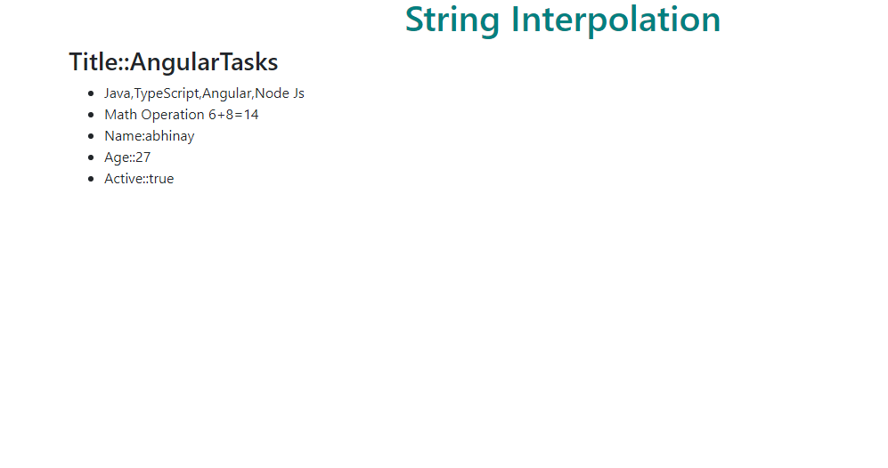

***Execution Flow:::***

